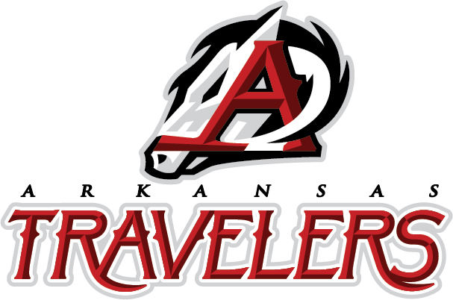

**Friday, August 8, 2025, at 7:05 pm**

**FIREWORKS AFTER THE GAME!**  
  
This is a Minor League [MiLB] Double A baseball game between the  
**Arkansas Travelers** (Mariners) and the **Tulsa Drillers** (Dodgers)

Dickey-Stephens Park   
400 W. Broadway North   
Little Rock, AR

**Transportation to the event is NOT provided.**

Each ticket is $25 and will include a seat at the game and access to the Club Car Picnic area reserved for the Sweepstakes Convention attendees. The picnic area will have a 2-hour all-you-can-eat buffet, including hamburgers, brats, hot dogs, chips, sodas, and sweet tea. Other snacks and beverages will be available for purchase. *Price also includes all taxes and fees for ticket and food.*

Guests can arrive as early as 6:05pm.  
Wristbands will be provided to paid attendees on Thursday during registration. Convention Attendee must pick up wristbands.

***Orders and payment must be received by 7/11/25.***

**Name of Convention Attendee**

Name: __________________________________

How many tickets needed: ___x $25 each: Total price to be paid: $______

*Tickets are not just for attendees. Friends & family are welcome.*

*After you fill this form out, please email it to* [*lilrocevent@yahoo.com*](mailto:lilrocevent@yahoo.com) *and confirm how you will be paying.*

Payment can be made by Paypal or check. If you are mailing a check, it must be received by 07/11/2025 so that we can confirm the number of wristbands needed.

Mail Check to: Shawna Yonts

9 Magnifico Lane

Hot Springs Village, AR 71909