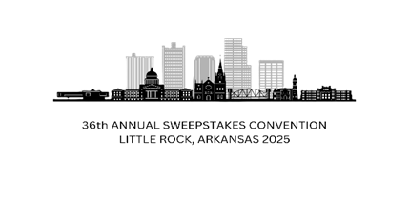AFTER PARTY REGISTRATION

~~$425 if~~ **~~received by~~** ~~or before November 4, 2024~~

~~$475 if~~ **~~received between~~** ~~November 4, 2024 and February 16, 2025~~

$500 if **received between** February 17, 2025 and May 19, 2025

*** After Party Registrations will not be accepted after May 19, 2025***

*** Refunds for the After Party are only available if you cancel your convention registration****

~~90% refund if the request is received on or before September 30, 2024~~

~~75% refund if the request is received between October 1, 2024 and December 31, 2024~~

50% refund if request is received between January 1, 2025, and March 31, 2025

25% refund if the request is received between April 1, 2025, and May 19, 2025

We are not able to offer refunds after May 19, 2025. However, anyone who cancels their after-party registration between May 19, 2025, and June 30th will be entered into a drawing to win $200.

Name_________________________________________________________________________________

Email_________________________________________________________________________________

City___________________________________________________________________________________

State__________________________________________________________________________________

Please **do not** send cash

Make Checks or Money Order Payable to:

LR National Convention, LLC

c/o Shawna Yonts

9 Magnifico Ln

Hot Springs Village, AR 71909